CS476 Team Standards Document

Transit Trackers

3 October 2024

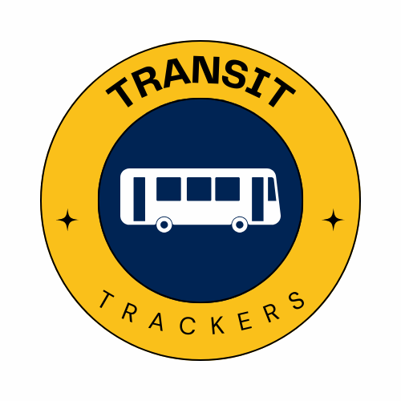

Drake Stanton, Lauren Bushman,

Alonso Jimenez Alamilla, Benjamin Griepp

NAU Shuttle Services

Paul Deasy

**Introduction**

This document will outline the standards to which all members of our team, Transit Trackers, will be held for the duration of CS476 and CS486. This includes the expected responsibilities and contributions of the team member roles, a guideline and expectations for regular team meetings, the agreed upon standards for all deliverables, documents, and code produced, as well as what development tools will be used by the team, and an outline of the team self-review process.

**Team Members and Roles**

The following individuals are considered **team members:** Drake Stanton, Lauren Bushman, Alonso Jimenez Alamilla, Benjamin Griepp. Team members are expected to attend all meetings as outlined in the Team Meeting Expectations section, contribute to deliverables and code, and complete all other tasks assigned to them.

Drake Stanton is the **team lead**. The team lead is responsible for communicating with the client and mentor, arranging meetings, and letting the team know due dates and mentor expectations for deliverables. The team lead will also send the weekly task report to the mentor before each mentor meeting.

Other roles: these roles will be assigned as needed, and are subject to change or be added upon as development progresses.

* **Recorder:** this role is responsible for taking thorough notes at all meetings and relaying the information to the rest of the team. The current recorder is Alonso.
* **Quality assurance:** this role is responsible for ensuring all code is of high quality and fits with the team's style standards before it is merged into the main branch. Ben and Lauren are currently quality assurance.
* **Release manager:** this role will be responsible for ensuring that a working version of the project is stable and follows all requirements and specifications before it is released to the client. Current release manager is Drake.
* **Programmer:** All team members are expected to contribute to the project code. More specific programming responsibilities will be given to each programmer as development progresses.

**Team Meeting Expectations**

**Meeting Times:**

* Mentor Meetings: Mentor meetings will take place on Thursdays at the SICCS building from 11:30-12:30 or virtually as needed.
* Client Meetings: Meetings with the client will be held bi-weekly remotely on Wednesdays at 2:30, or in-person as needed.
* Team meetings: Meetings with the team will be held after class on Fridays at the Engineering building or remotely. Additional meetings may be scheduled as needed.

**Agenda Structure:** Every meeting will begin with a recap of what each team member has been working on and their progress and or challenges they have been encountering. Meetings will then segue into what we need to accomplish that week and a recap of what deadlines we need to meet. Next will be preparing for meetings with the client and mentor to make sure that the team is prepared for when we meet with them. The rest of the meeting will be time for us to either work on things together or provide support for team members who need it. The end of the meeting will be a summary of what we discussed and again highlight deadlines that we need to meet.

**Decision-Making Process:** The team discussed that when it comes to disagreements on design choices or other aspects of decision-making making a ¾ majority will be required to settle the dispute.

**Attendance:** It is expected that all group members will be able to attend the majority of the meetings that are held. When a team member must miss a meeting, they will let the group know at least a few hours in advance and will do the work to get any missed information from another team member. They will complete any tasks that were assigned to them at the meeting.

**Conduct:** Conduct for meetings requires team members to attend the meeting on time, be well prepared, and be polite and respectful to the mentor and client. When it comes to interpersonal disputes the process will be as follows: Meeting as a team to address the dispute, if the dispute is not resolved then bring a third party such as a peer to get a different perspective. If that does not work it will be escalated to a discussion with our mentor or professor. For non-participating team members, the first course of action will be a polite heads-up followed by a team discussion about it. In the team meeting, we will discuss the challenges said team members might be facing and if they need support or if they need to be reassigned to a different task. If that does not resolve the issue the discussion will be escalated to the mentor and then the capstone organizer to determine if further action is needed.

**Tools and Document Standards**

**Version Control: Github** - One repository for project development, one repository for the team website, each member will have their own branch with branch protection for the main branches requiring all merges to be approved by another team member first.

**Issue Tracking: Github** - Issue tracking will be done in the main project repository with tags for team documents, code implementation, bug fixing, and code optimization. Issues will be assignable to any team member and resolved on document completion or branch merge.

**Word Processing: Google Docs** - Allows real time collaboration on document deliverables and integrates well with Google Drive where team documents are kept.

**Presentation: Google Slides -** Allows real time collaboration on presentation deliverables and integrates well with Google Drive.

**Design: Figma -** Allows real time collaboration on web design planning and provides tools that integrate well with different web design standards and layouts.

**Composition and Review: Google Drive/Docs/Discord** - Channel in team Discord server keeps track of deliverable due dates and role assignments, including a lead editor, while all team documents are stored in Google Drive as Google Docs. Team deadline will be 24 hours before the due date to ensure time for finishing touches if necessary.

**Team Self Review**

We will conduct Team Self Reviews biweekly (one on, one off) after the end of our weekly meetings. We will sit all next to each other while we conduct our team self review. The team will verbally discuss the following questions, with notes taken by the team recorder.

* How much did we do this week (in the scope of our project)?
* What things did we do well?
* What things didn’t we do well?
* How can we improve?
* What is one goal we can set and achieve for next week?

We will write down our responses to each of these questions in a Google Doc. This will be done (by our team recorder) in order to hold each other accountable in terms of meeting our goals and improving our work in this project. These Google Docs will be stored in our shared folder. We will talk about each of the questions and our answers and try to provide feedback for each other, as well as feedback towards ourselves individually.

While the questions we ask and answers we give will be leaning towards the technical side of our project, we hope to also improve some crucial soft skills that go into working side by side with other team members when tasked with a collaborative project.

We are hoping to have a casual and informal self review, simply discussing each of these four topics in order and bouncing off each other to hopefully get meaningful conversation towards delivering the most complete and accurate project we can produce.